Final Project Write up

Roman Yushchyk

200368308

Stargate Alarm Clock

**Introduction:**

This project was inspired by one similar project on internet. You can find it by following this [link](http://howtomechatronics.com/projects/arduino-touch-screen-music-player-alarm-clock-project/).

I also borrow a few pictures to make an example from the website above.

Rather than going with a poorly designed display I choose to replace it with a more compact mcufriend touchscreen. This leads to a change of library and I have to code the whole alarm clock and a user interface all by myself. I started with a similar layout for the code and modified it as I go.

First of one we need to copy libraries from this repository to your computer.

Second step is to band pins 11, 12, 13 to 90 degrees to allow faster download speed.

Here how it looks from below before bending pins on this TFT.

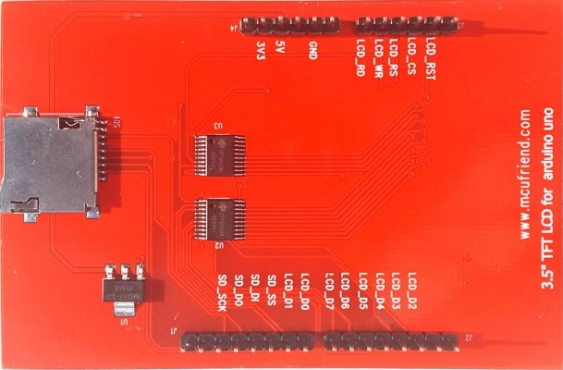

Pins marked **SD_SCK (Clock)** – pin 50(mega2560), **SD_D0**(Data out) – pin 52 (Mega2560) and **SD_D1**(Data in) – pin 51(Mega 2560) pins need to banded at 90 degrees to enable native SPI on Arduino Mega2560. Simply run jumpers to each pin accordingly.

Here is how new TFT SD card wiring looks like after doing steps above.

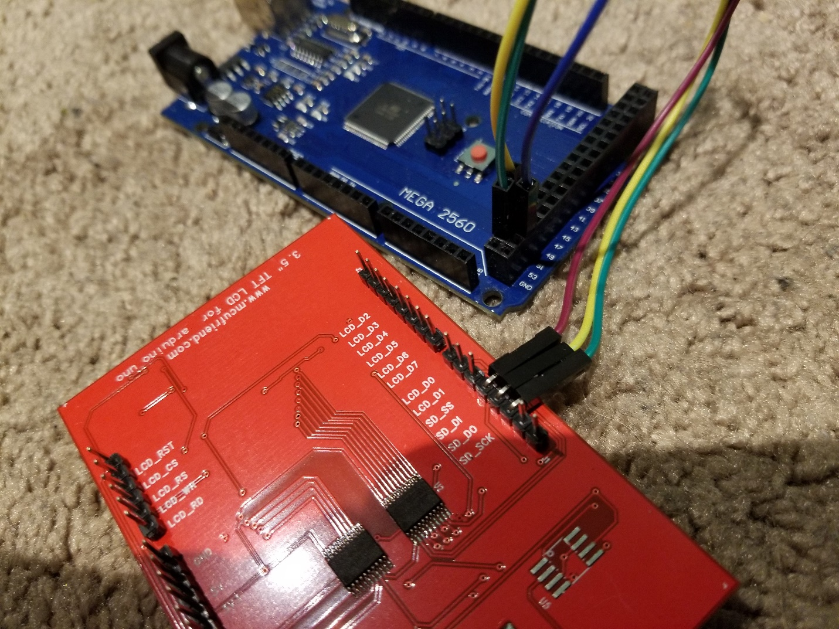

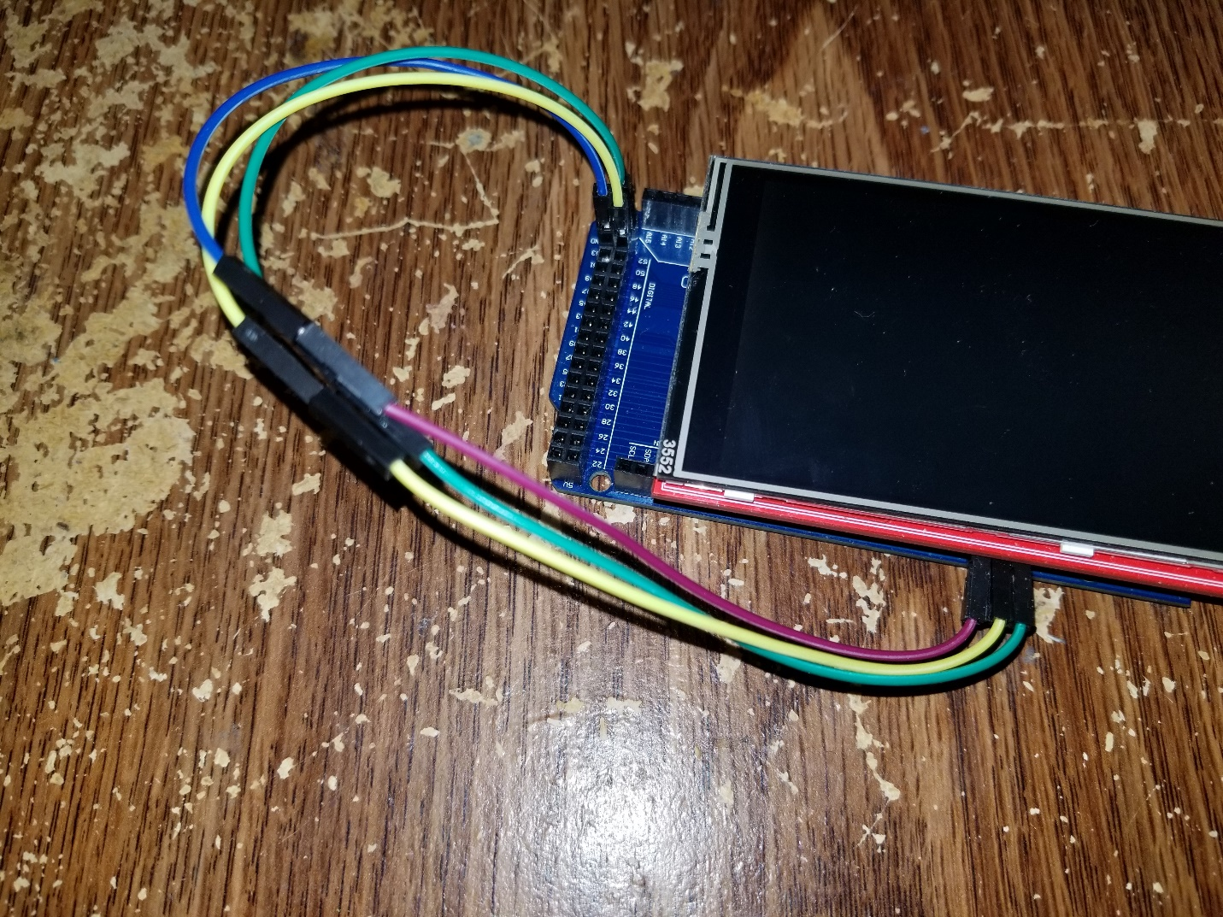

By using SDFat library rather than SD and Software Serial instead of SPI we increased loading speed by a factor of two. It dropped from an average of 10 seconds for 480 X 320 bmp to half of it, just 5 seconds.

SDFat load time is only 5 seconds for an arrearage background. You can change drawHomeScreen() function to just fill it blank black for or debagging purpose. Simply uncomment one and comment other one with a sign // 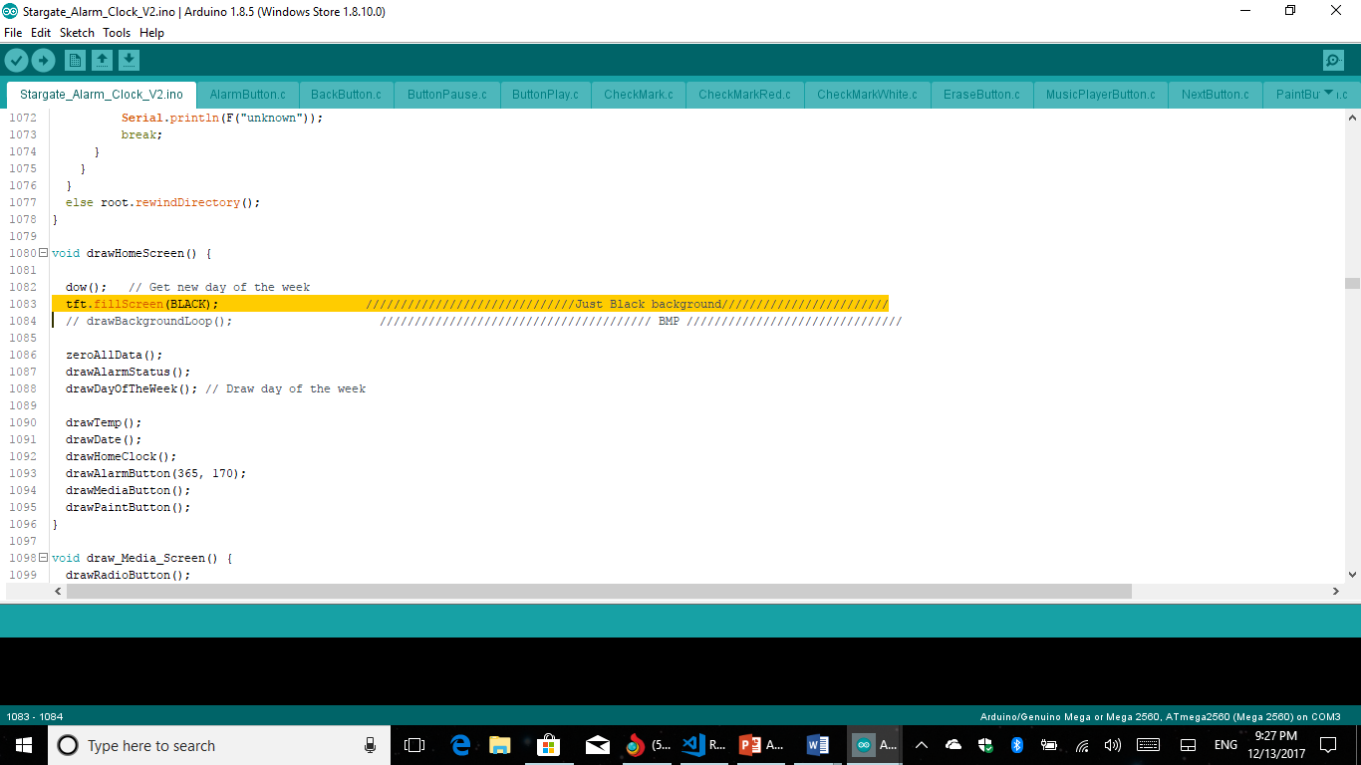

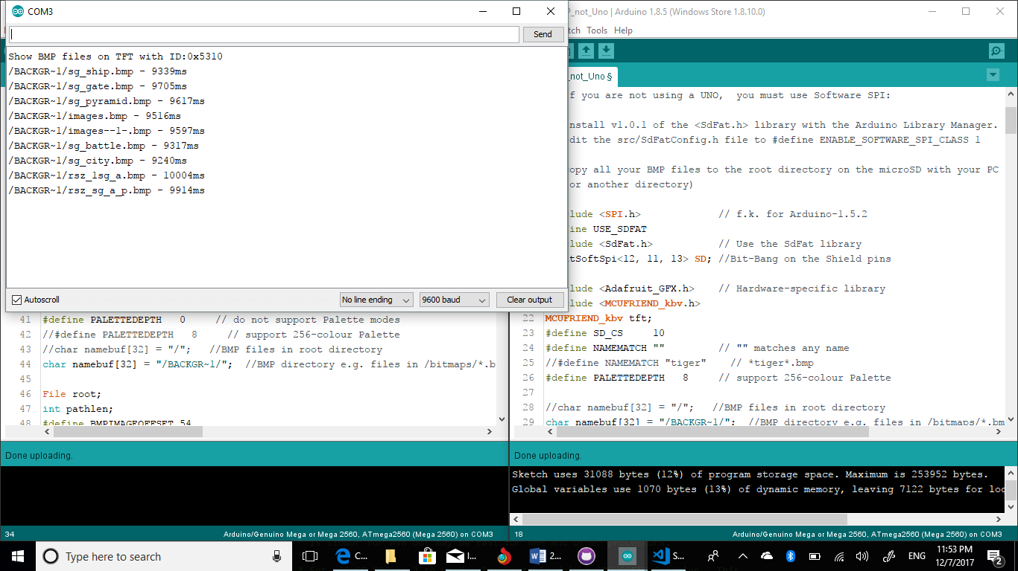

Upload time for a picture without a hardware modification.

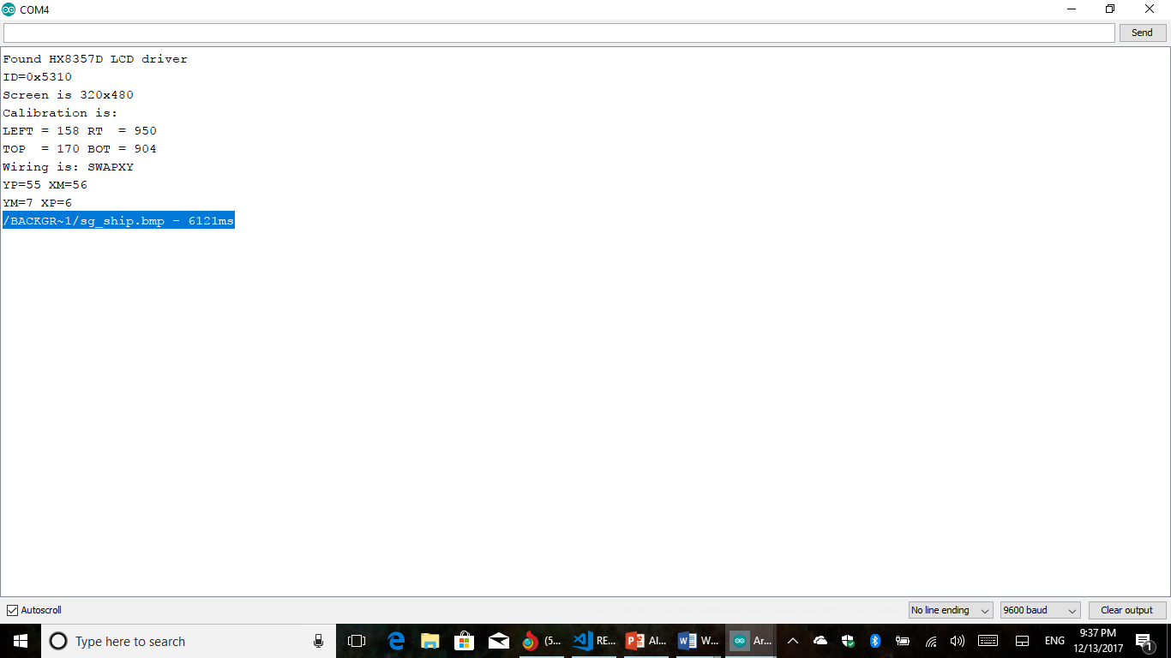

Upload time for an integrated code with a background picture.

Let’s take a look at the RTC clock. RTC connection did not changed and you can set a clock and date from the setup loop.

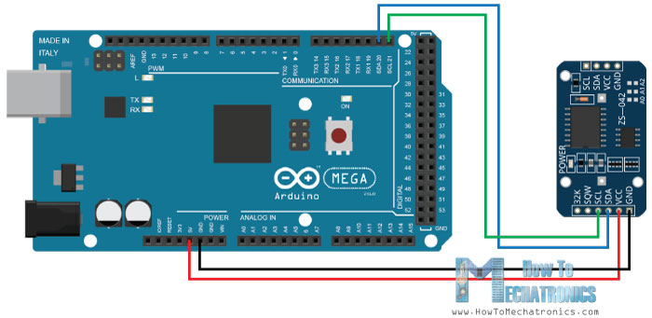

Wiring for a MP3 player has changed a little. I’m using pins 13, 12, which was made free by the SD card bypass.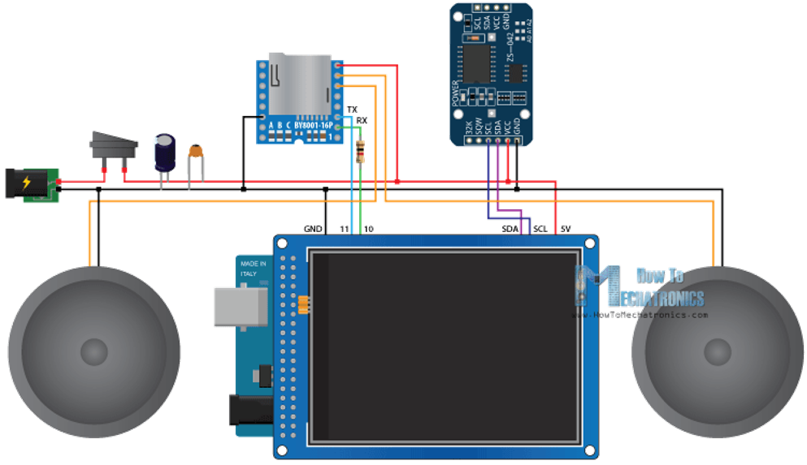

To make it compact I decided to solder my wires directly onto my mega. To prevent lose ends while I use my alarm.

Mercury tilt switch is connected to the pin number 11 in my case.

Let’s move on to the code logic.

My code: